MAQUINA 2
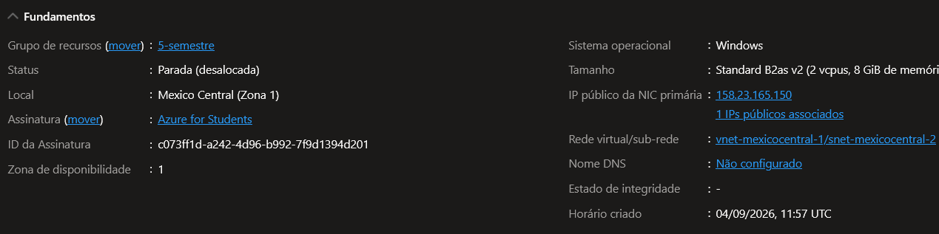
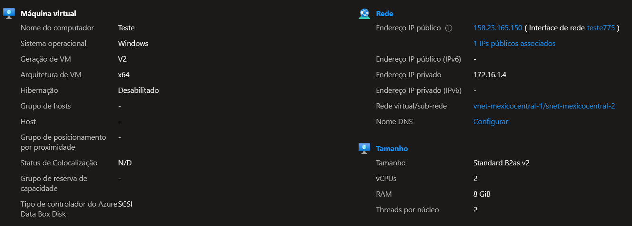

{
"name": "Teste",
"id": "/subscriptions/c073ff1d-a242-4d96-b992-7f9d1394d201/resourceGroups/5-semestre/providers/Microsoft.Compute/virtualMachines/Teste",
"type": "Microsoft.Compute/virtualMachines",
"location": "mexicocentral",
"properties": {
"hardwareProfile": {
"vmSize": "Standard_B2as_v2"
},
"provisioningState": "Succeeded",
"vmId": "5027d73c-14f0-459e-9c40-2499ac4764f8",
"additionalCapabilities": {
"hibernationEnabled": false
},
"storageProfile": {
"imageReference": {
"publisher": "microsoftwindowsdesktop",
"offer": "windows-11",
"sku": "win11-25h2-pro",
"version": "latest",
"exactVersion": "26200.9168.260809"
},
"osDisk": {
"osType": "Windows",
"name": "Teste_OsDisk_1_adfdd6c256774cd4becac9806f55e7de",
"createOption": "FromImage",
"caching": "ReadWrite",
"managedDisk": {
"id": "/subscriptions/c073ff1d-a242-4d96-b992-7f9d1394d201/resourceGroups/5-semestre/providers/Microsoft.Compute/disks/Teste_OsDisk_1_adfdd6c256774cd4becac9806f55e7de"
},
"deleteOption": "Delete"
},
"dataDisks": []
},
"osProfile": {
"computerName": "Teste",
"windowsConfiguration": {
"provisionVMAgent": true,
"enableAutomaticUpdates": true,
"patchSettings": {
"patchMode": "AutomaticByOS",
"assessmentMode": "ImageDefault",
"enableHotpatching": false
}
},
"secrets": [],
"allowExtensionOperations": true,
"requireGuestProvisionSignal": true,
"adminUsername": "MatheusHenriqueDevz"
},
"securityProfile": {
"uefiSettings": {
"secureBootEnabled": true,
"vTpmEnabled": true
},
"securityType": "TrustedLaunch"
},
"networkProfile": {
"networkInterfaces": [
{
"id": "/subscriptions/c073ff1d-a242-4d96-b992-7f9d1394d201/resourceGroups/5-semestre/providers/Microsoft.Network/networkInterfaces/teste775",
"properties": {
"deleteOption": "Detach"
}
}
]
},
"diagnosticsProfile": {
"bootDiagnostics": {
"enabled": true
}
},
"licenseType": "Windows_Client"
},
"zones": [
"1"
]
}

